National Trends in Surgery for Sinonasal Malignancy and the Effect of Hospital Volume on Short Term Outcomes

David Ouyang1, Ivan El-Sayed2, Sue S. Yom12

Institutions: 1. Department of Radiation Oncology, University of California, San Francisco, San Francisco, CA, United States, 2. Department of Otolaryngology-Head and Neck Surgery, University of California, San Francisco, San Francisco, CA, United States

Corresponding Author:   
Sue S. Yom, MD, PhD  
Department of Radiation Oncology

Helen Diller Family Comprehensive Cancer Center

University of California, San Francisco

1600 Divisadero St. Suite H-1031

San Francisco, CA 94143   
[415-353-9893](tel:415-353-9893)  
[yoms@radonc.ucsf.edu](mailto:yoms@radonc.ucsf.edu)

Keywords: Paranasal Cancer, Sinonasal Surgery, National Inpatient Sample  
Running Title: Trends in Sinonasal Cancer Surgery

Tables: 4

Figures: 1

Supplemental Figures: 5  
  
Word Count:

**Abstract**

Background: Sinonasal carcinomas are rare, highly morbid neoplasms originating in the nasal cavity and paranasal sinuses. The mainstay of treatment over the past two decades has been a combination of surgery, radiation, and chemotherapy. We sought to characterize trends in the initial management of sinonasal malignancy with a particular focus on the impact of hospital volume on surgical care and outcomes.

Methods: A retrospective cohort study was conducted examining time trends among patients admitted for surgical resection of sinonasal malignancy in the National Inpatient Sample (NIS) between 1988 and 2009. Subset analysis of high risk cases was performed on patient cohorts with skull base involvement, orbital or maxillary sinus involvement, or who underwent neck dissection. Patient characteristics as well as hospital attributes were correlated with patient morbidity and mortality.

Results: Over the course of 22 years, we identified 3850 cases of sinonasal surgery patients from 879 hospitals. 24.3% of patients had complications ranging from infections, cardiopulmonary complications, neuropathy, visual disturbances, and electrolyte abnormalities and 0.8% of hospitalizations resulted in mortality. Cases with skull base, orbital or maxillary sinus involvement, or including neck dissection had more complications (29.4% vs. 23.2%, p < 0.001) and a longer length of stay (9.34 days vs. 6.12 days, p < 0.001). There was an increase in the number of cases with neck dissection over the time period studied.

Thirty-two hospitals averaged more than 5 cases per year, accounting for 28% (1097) of all sinonasal surgeries. These high-volume centers were predominantly large (73.3%), urban (96.7%), teaching (90%) institutions and performed more high risk cases – accounting for 32.4% of cases including neck dissection, 44.6% of cases with orbital involvement, and 43.1% of cases with skull base involvement. Compared to low-volume centers, high-volume centers had more cardiopulmonary complications (21.1% vs. 17.8%, p = 0.024) and electrolyte abnormalities (10.4 vs. 7.2%, p = 0.018), however there was no difference in the length of stay. Over the time period studied, a greater proportion of cases were recently performed at high-volume centers.

Conclusions: This study characterizes current trends in the initial management of sinonasal cancer. There is an increased likelihood that complicated surgeries are performed at higher-volume hospitals which also entails a higher complication rate. High risk cases resulted in higher rates of complications but were not associated with a higher mortality rate.

**Introduction**

Sinonasal cancers are uncommon – accounting for only between 1 – 3% of head and neck cancers [1,2]. A wide range of tumors can originate in the nasal cavities including squamous cell carcinoma, adenocarcinomas, and neuroendocrine carcinomas. Sinonasal carcinomas are typically asymptomatic until they progress to an advanced stage with local invasion and a potential constellation of symptoms including chronic nasal discharge, epistaxis, nasal obstruction, anosmia, neuropathies, proptosis, edema, and visual disturbances. Depending on the tumor type, regional lymph node or distant metastases occur with varying frequency. Due to proximity to vital structures such as the orbit, carotid artery, and brain, primary tumors frequently present as advanced disease.

Given the low incidence and heterogenous histology of sinonasal cancers, there are no randomized trials indicating the optimal management. Management of sinonasal cancers varies with histology, but the current standard approach has traditionally been combined modality treatment with surgery and radiotherapy for advanced stage disease with or without chemotherapy. Several retrospective studies suggest that improved local control is achieved when surgery is employed, however selection bias mitigating against unresectable tumors may influence the poorer results with radiation [22].

A few institutions have published their experiences with sinonasal cancers [1,3,4,5,6,7], but these institutional case series each contain fewer than 75 patients and represent differing perspectives related to treatment and overall approach to sinonasal cancers over prolonged time periods. The University of Florida experience using primarily radiotherapy-only approach and combined radiotherapy surgical approach found the control rate with radiotherapy alone was 43%, while combined modality was 84% with primary surgery followed by radiation [3] Similarily the M.D. Anderson Cancer Center experience with more inclusion of surgery and post-operative radiotherapy achieved 82% 5-year survival. Case studies employing a variety of treatment regimens have suggested a rate of local recurrence of 28-41% and 5-year actuarial survival rates of 40-82% [1,3,4,5,6,7].

While surgery in combination with radiation plays a definitive role in the management of many sinonasal cancers, limited data exists regarding the patterns of surgical care as it is delivered across the United States. Sinonasal and skull base surgery is a specialized enterprise that benefits from the deployment of a multidisciplinary team, with high potential for immediate severe life threatening complications which may require urgent surgical intervention. There is little data in the context in which surgery for sinonasal cancer is performed, where high risk surgeries were performed, or whether there is variation in outcomes between high and low volume surgical centers. We sought to examine contemporary patterns of sinonasal cancer surgery in the United States over a period between 1988 to 2009. In this study, through analysis of a national inpatient database, we investigate the short-term surgical outcomes of sinonasal cancer surgery patients and evaluate the impact of hospital volume on short-term outcomes.

**Materials and Methods**

**Data Source**

A retrospective cross-sectional analysis of patients who underwent surgical resection of primary cancer of the nasal cavities and paranasal sinuses was performed using data from the National Inpatient Sample (NIS) from the Healthcare Cost and Utilization Project, Agency for Healthcare Research and Quality. The NIS is the largest database of all-payer inpatient discharge information, sampling approximately 20% of all non-federal US hospitals and including approximately 9 million hospital admissions each year. Each NIS entry includes all diagnosis and procedure codes of activity during the patient’s hospitalization at the time of discharge as well as patient demographics, hospital characteristics, and short-term complications of the hospitalization.

**Data Extraction**

All available data from 1988 through 2009 were queried. Patients admitted for primary head and neck cancer with a primary procedure of surgical resection in the maxillary, frontal, ethmoid, or sphenoid sinuses were identified. Higher-risk surgeries were identified by associated orbit, maxillary sinus, or skull base surgical codes as well as surgeries requiring neck dissection. Hospital mortality and perioperative morbidity such as post-operative infections, cardiopulmonary complications, hemorrhagic complications, nerve palsies, and deep vein thrombosis were identified.

**Statistical Analysis**

The total number of hospitalizations was plotted annually from 1988 to 2009 and hospital volume was assessed for each hospital in the database. Hospital-level data was stratified by hospital caseload to compare complication rates between high- and low-volume hospitals. The Pearson chi-square test was used to analyze differences in low-volume and high-volume hospitals as well as differences in complication rates. Logistic regression models were used to assess the influence of patient demographics and hospital characteristics on complication rates. All analyses were performed using Python 2.7 (Python Software Foundation, www.python.org) and R 2.13 (R Foundation, www.r-project.org).

**Results**

We identified 3850 cases of sinonasal surgery between 1988 and 2009 (Figure 1). Patients had a mean age of 61 years and stayed on average 6.8 days in the hospital. Consistent with previous accounts, we found a male predominance, comprising 57.2% of all patients. Aggregate patient race, sex, age, and insurance status did not vary between high and low volume centers (Table 1), and the overall demographics have not changed over time (Supplemental Figure A, B, C). The volume of sinonasal cancer surgery has not changed appreciably over the last twenty years, but a greater proportion of these surgeries are now being performed at higher-volume centers (Figure 1, R2 = 0.268, p > 0.001).

|  |  |  |  |  |  |  |  |  |  |  |  |
| --- | --- | --- | --- | --- | --- | --- | --- | --- | --- | --- | --- |
| **Table 1.** Patient Demographics for Sinonasal Cancer Surgery | | | | | | | | | | | |
|  |  | | **High Volume Centers  (>=5 Cases/Year)** | | | | **Low Volume Centers (<5 Cases/Year)** | | | |  |
| Age, mean (SD) | | | 59.8 ± 14.3 | | | | 62.0 ± 17.2 | | | |  |
|  |  | |  | |  | | | |  | | |
| Sex, n (%) | Female | | 424 (40.0) | | | | | 1214 (43.5) | | |  |
|  | Male | | 633 (60.0) | | | | | 1568 (56.2) | | |  |
|  |  |  | |  | | | |  | |  | |
| Race, n (%) | White | | 632 (59.6) | | | | | 1424 (51.1) | | |  |
|  | Black | | 53 (5.0) | | | | | 214 (7.7) | | |  |
|  | Hispanic | | 54 (5.1) | | | | | 163 (5.8) | | |  |
|  | Asian/Pacific Islander | | 30 (2.8) | | | | | 65 (2.3) | | |  |
|  | Native American | | 1 (0.1) | | | | | 9 (0.0) | | |  |
|  | Other or unknown | | 271 (26.0) | | | | | 879 (31.5) | | |  |
|  |  | |  | |  | | | |  | | |  |
| Primary payer, n (%) | Private | | 440 (41.5) | | | | | 1288 (46.2) | | |  |
| Medicaid | | 69 (6.5) | | | | | 214 (7.7) | | |  |
|  | Medicare | | 480 (45.2) | | | | | 1066 (38.2) | | |  |
|  | Self-pay | | 40 (3.8) | | | | | 75 (2.7) | | |  |
|  | Other or unknown | | 27 (2.5) | | | | | 110 (3.9) | | |  |
|  |  | |  | |  | | | |  | | |  |
| **Total, n (%)** |  | | **1061(28.5)** | | | **2789 (71.5)** | | | | |  |

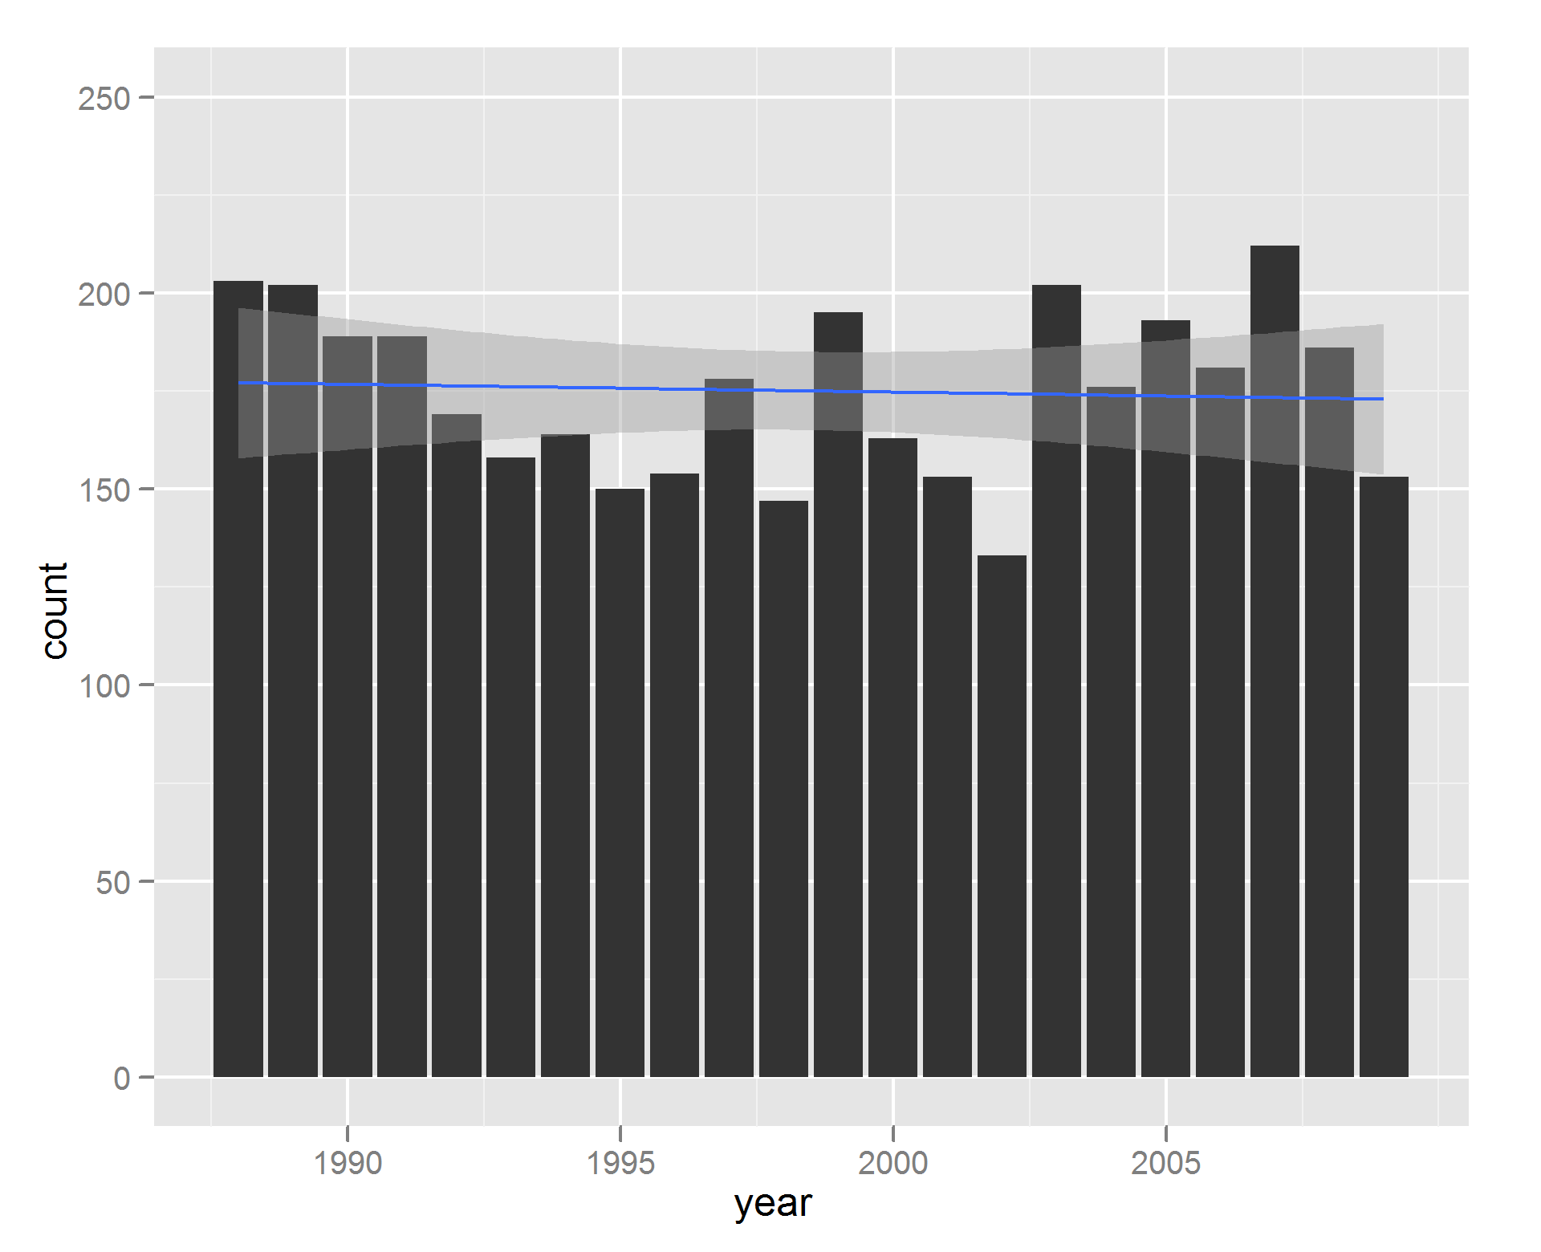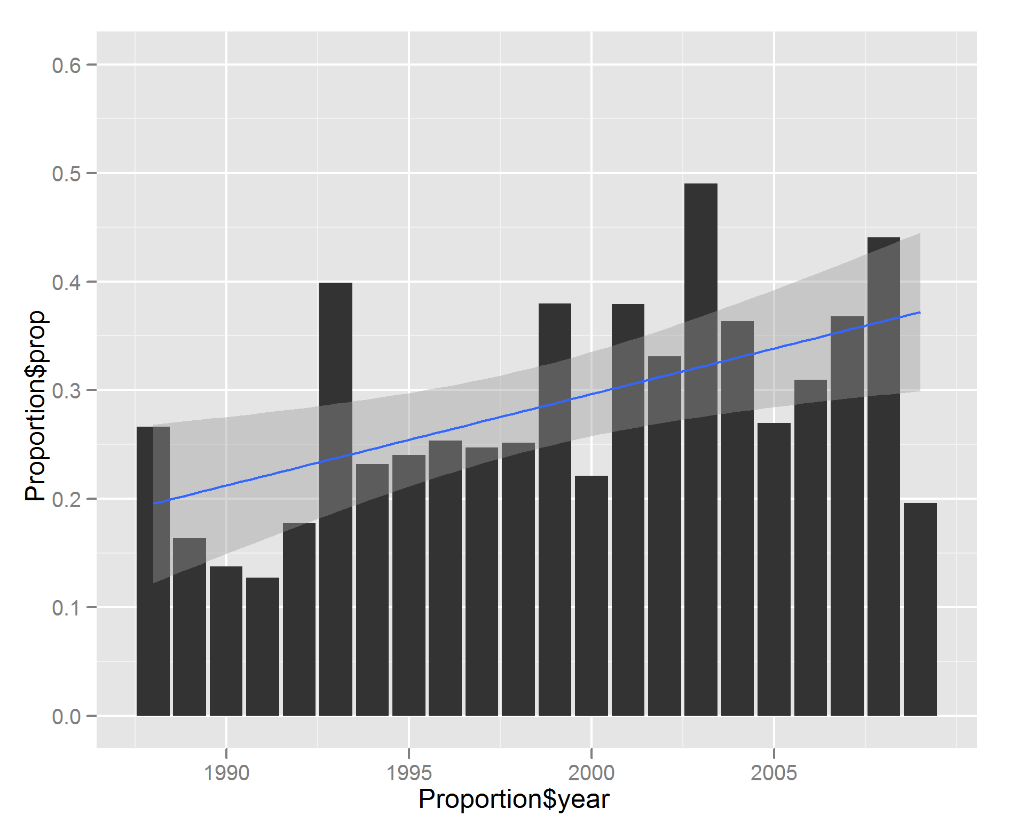

**Figure 1: The number of sinonasal cancer surgeries has not changed significantly over the last twenty years, however an increasing proportion of these surgeries are performed at high volume centers. A: Total number of sinonasal cancer surgeries per year. B: Proportion of sinonasal cancer surgeries performed at high volume centers per year.**

In order to investigate the impact of surgical volume on short-term outcomes, we separated hospitals into centers that perform relatively higher numbers of sinonasal cancer surgery cases (greater than 5 cases per year) and centers that performed relatively few sinonasal cancer surgery cases (less than 5 cases per year). Thirty two hospitals which averaged more than 5 cases per year were identified and accounted for 28% of all sinonasal surgery cases. These hospitals were more frequently represented in high-risk cases, accounting for 32.4% of all cases requiring neck dissection, 44.9% of cases with orbital involvement, and 45.7% of cases with skull base involvement, despite comprising only 3.6% of all hospitals that performed sinonasal cancer surgery (Table 2). At high-volume centers, 26.1% of cases were high-risk cases, compared to 15.0% of cases at low-volume centers. High-volume centers tended to be teaching hospitals (P > 0.001), and large, urban hospitals were also more represented (Table 3).

|  |  |  |  |  |  |  |
| --- | --- | --- | --- | --- | --- | --- |
| **Table 2.** Number of Hospitals, Sinonasal Cancer Surgeries Stratified by Hospital Caseload | | | | | |  |
|  | **1988 to 2009** | | | | |  |
|  | **Hospitals, n (%)** | **Cases (%)** | **Cases with Neck Dissection (%)** | **Cases with Orbital Involvement (%)** | **Cases with  Skull Base Involvement (%)** | **Complicated Cases,  Total (%)** |
| High Volume Hospitals (>5 Cases/Year) | 32 (3.6) | 1061 (28.5) | 79 (32.4) | 106 (44.6) | 128 (43.1) | 277 (38.7) |
| Low Volume Hospitals (<5 Cases/Year) | 847 (96.4) | 2789 (71.5) | 165 (67.6) | 130 (53.4) | 169 (56.9) | 418 (61.3) |
| **Total** | **879 (100)** | **3,850 (100)** | **244 (100)** | **236 (100)** | **297 (100)** | **715 (100)** |
|  |  |  |  |  |  |  |

|  |  |  |  |  |  |  |  |  |
| --- | --- | --- | --- | --- | --- | --- | --- | --- |
| **Table 3.** Hospital Characteristics of Admissions for Sinonasal Cancer Surgery | | | | | | | | |
|  | |  | **High Volume Centers  (>5 Cases/Year)**a | | | **Low Volume Centers (>5 Cases/Year)**a | |  |
| Hospital size, n (%)b | Small | | 3 (10.0) | | | 113 (13.6) | | |
| Medium | | 5 (16.7) | | | 254 (30.7) | | |
|  | Large | | 22 (73.3) | | | 461 (55.7) | | |
|  |  | |  |  | | |  | |  |
| Hospital type, n (%) | Teaching | | 27 (90.0) | | | 346 (41.8) | | |
| Non-teaching | | 3 (10.0) | | | 482 (58.2) | | |
|  |  | |  |  | | |  | |  |
| Hospital location, n (%) | Urban | | 29 (96.7) | | | 707 (85.4) | | |
| Non-urban | | 1 (3.3) | | | 121 (14.6) | | |
|  |  | |  |  | |  | | |  |
| Complex Cases,  n (%)c | Neck Dissection | | 79 (7.4) | | | 165 (5.9) | | |  |
| Orbital Involvement | | 106 (10.0) | | | 130 (4.7) | | |  |
| Skull Base Involvement | | 128 (12.0) | | | 169 (6.1) | | |  |
|  | |  |  |  | |  | | |  |
| **Total, n (%)** | |  | **32 (100.0)** | | **847 (100.0)** | | |  |
| Data are cumulative, 1988-2009. aHospital characteristics were not found for 2 high volume hospitals and 19 low volume hospitals.  bHospital size classification is dependent on number of beds and hospital type. For example, for urban, teaching hospitals, “small” signifies < 300 beds and “large” signifies > 500 beds. cPercentage obtained from total number of cases by each subset | | | | | | | | |

Less than 1% of hospitalizations resulted in short-term mortality and 36.9% of patients had complications ranging from neuropathies and visual impairment to infections and cardiopulmonary arrest (Table 4). Cardiopulmonary complications were the most common class of complications, representing about half of all complications, while visual defects and neuropathies directly resulting from the surgery was present in a minority of cases. There was a statistically significant difference in overall complication rate between high-volume and low-volume centers (Chi-squared test, p = 0.018), with higher rates of cardiopulmonary complications (p = 0.024) and peri-operative electrolyte abnormalities (p = 0.002) seen at high-volume centers. There was no difference in mortality between high-volume and low-volume centers (p = 0.122). High-volume centers had longer lengths of stay compared to low-volume centers (7.79 days vs. 6.31 days, p < 0.001) and this difference was sustained even with direct comparision of high risk cases between high and low volume centers (10.58 days vs. 8.59 days, p = 0.003) and non-high risk cases between high and low volume centers (6.84 days vs. 5.89 days, p = 0.004).

There were 715 cases that included neck dissection, had orbital or maxillary sinus involvement, or had skull base involvement, of which 277 were performed at high-volume centers and 418 were performed at low-volume centers. Two cases had surgeries that met all three criteria and 59 patients had surgeries that met two of the three criteria. Patients with high risk surgery had longer lengths of stay (9.34 days vs. 6.13 days, p < 0.001) and had higher rates of morbidity and mortality. Among these high-risk surgeries, 29.4% resulted in the listed complications, compared to 23.2% of cases without such extra-sinonasal intervention (p < 0.0001). For complicated cases, there was no observed difference in mortality between high-volume and low-volume centers.

|  |  |  |  |  |  |  |  |
| --- | --- | --- | --- | --- | --- | --- | --- |
| **Table 4.** Complications of Sinonasal Cancer Surgery | | | | | | | |
|  | **Total** | **High-Volume Centers** | | **Low-Volume Centers** | | | **Pa** |
| Deaths, n (%) | 30 (0.8) | 4 (0.4) | | 26 (0.9) | | 0.122 | |
|  |  |  | |  |  | | |
| Infectious, n (%) |  |  | |  | | 0.119 | |
| Surgical Site Infection | 70 (1.8) | 14 (1.3) | | 56 (2.0) | |  | |
| Urinary Tract Infections (UTIs) | 71 (1.8) | 16 (1.5) | | 55 (2.0) | |  | |
| Pneumonia | 30 (0.8) | 9 (0.8) | | 21 (0.8) | |  | |
| Unspecified Postop Infection | 17 (0.4) | 3 (0.2) | | 14 (0.5) | |  | |
|  |  |  | |  | |  | |
| Cardiopulmonary, n (%) |  |  | |  | | 0.024b | |
| Stroke | 16 ((0.4) | 8 (0.8) | | 8 (0.3) | |
| Cardiac Arrest | 8 (0.2) | 1 (0.1) | | 7 (0.3) | |  | |
| Other Cardiac Complications | 456 (11.8) | 127 (12.0) | | 329 (11.8) | |  | |
| Pulmonary Complications | 239 (6.2) | 87 (8.2) | | 152 (5.4) | |  | |
|  |  |  | |  | |  | |
| Other, n (%) |  |  | |  | |  | |
| Neuropathies  Visual Impairment | 51 (1.3) | 13 (1.2) | | 38 (1.4) | | 0.861 | |
| 76 (2.0) | 20 (1.9) | | 56 (2.0) | | 0.908 | |
| Hemorrhage | 46 (1.2) | 12 (1.1) | | 34 (1.2) | | 0.953 | |
| Electrolyte Abnormalities | 312 (8.1) | 110 (10.4) | | 202 (7.2) | | 0.002b | |
|  |  |  |  | | |  | |
| **Total Complications** | **1392 (36.9)** | 424 (40.0) | | 998 (35.8) | | 0.018b | |
| aChi Square Test Comparing High-Volume and Low-Volume Centers. b P < 0.05 | | | | | | | |

Over the period between 1988 and 2009, the number of cases per year has remained relatively constant over time, however a greater proportion of surgeries were performed at high-volume centers (p < 0.001). There was a decrease in mortality over time, however there was an increase in the rate of complications (Figure 3). The composition and distribution of the types of complications has not changed during the time period of analysis (Supplemental Figure D).

**Discussion**

Sinonasal cancers are a highly heterogeneous collection of morbid neoplasms often initially treated with surgery and adjuvant radiotherapy. Initially, these cancers can be clinically silent or mimic benign disease such as sinusitis or upper respiratory infections, resulting in late detection when cancers are advanced, as evidenced by a relatively high proportion of locally advanced disease extension at presentation. Demographic analysis reveals our findings are consistent with population based data from SEER, showing a male predominant patient population mostly between 50 – 70 years of age that has not significantly changed in incidence over the last twenty years [9]. Our data did not show significant changes over time in patient race or insurance status.

Tumor staging is not possible with the NIS, but paranasal sinus tumors are defined as advanced stage by spread beyond the paranasal sinuses to the cranial vault, orbit, or other local structures, or via lymphatic spread. Thus the prevalence of advanced disease at initial presentation is demonstrated by the fact that 26.1% of patients treated at higher volume centered underwent surgery with neck dissection, had orbit or maxillary sinus involvement, or had skull base involvement. The data reveals an increase in the number of complex cases over time, with an especially marked increase in the number of cases with neck dissection (Supplemental Figure E). Causes for this are not immediately clear and could be due to better detection of advanced disease, improved recognition of disease pathology, or more aggressive management philosophies. Previous case series have also shown between 39%-95% of cases present initially with advanced disease (Stage III or IV)[1,8]. In the NIS data, there was no trend over time towards less advanced disease, which is consistent with case series suggesting the proportion of advanced disease at first presentation has remained constant [4].

In the National Inpatient Sample, high-volume centers are more likely to perform more aggressive surgeries involving the skull base, orbit or maxillary sinus, and performed more neck dissection. Advances in surgical management of sinonasal cancer could explain the higher rates of referral over time to high-volume, experienced centers. Previous studies have shown decreased morbidity, decreased mortality, and deceased length of stays at high-volume centers for the surgical management of a variety of head and neck cancers [10, 11, 12]. High volume surgeons, more commonly found at high volume centers, have also been found to have decreased perioperative complications, improved long term survival in cancer, and reduced hospital costs [13 – 16]. These effects were especially seen in complicated cases [16]. Despite performing more aggressive surgeries, high volume centers had equal or lower rates of infection, neuropathy or visual impairment (despite more skull base and orbit surgery), and mortality. Particularly in cases with skull base involvement, it could be advantageous to have surgery at a high-volume center with an integrated approach with neurosurgical support. Alternatively, since this study lacks tumor staging data, it is possible that equivalently staged tumors are treated with less aggressive surgeries at low volume centers.

Although there has been an increase in the number of complex surgeries performed, there has been a decrease in perioperative mortality for sinonasal cancer surgeries. Prior studies of skull base surgery have demonstrated an improved mortality over the past 40 years primarily due to decreased infectious rates and better reconstructive techniques. This has allowed more aggressive, larger surgeries without an increase in mortality. The incidence of infectious complications has gone down over time, while there in has been an increase in the number of electrolyte abnormalities and cardiopulmonary complications.

Even though high-volume institutions provide care for more high-risk cases, but there was no difference in the mortality rate between high- and low-volume centers. There was no difference in the incidence infectious complications, surgical complications (neuropathies, visual disturbances, or hemorrhage), or length of stay. High-volume institutions had a higher rate of cardiopulmonary complications and electrolyte complications, suggesting that perhaps larger surgeries were attempted which required more aggressive volume resuscitation. Higher rates of these two categories of complications are the primary contribution to an increased overall complication rate at high volume hospitals.

A limitation of this study is that the National Inpatient Sample does not keep track of long-term outcomes from these hospitalizations. While we were able to show there is little perioperative mortality (0.8%), we were unable to examine long-term survival or complications. Further investigation would be necessary to compare the efficacy of various treatment options.